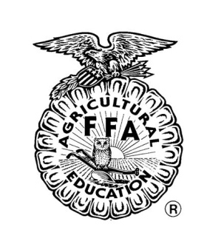
Collierville FFA Permission Slip
Permission Form

I give my permission for my son/daughter to be able to attend all chapter FFA trips, because these trips are part of education program. My Son/Daughter will adhere to the Code of Conduct for day or overnight trips as well as the applicable provisions of the general Code of Conduct. Students must remember that from the time of their departure to their arrival home they are the responsibility of the District.

I_____________________ agree to:
Student’s Name

- Refrain at all times from the consumption of alcoholic beverages and/or drugs unless said drugs are prescribed by a physician.

- Sleep in my assigned room and not entertain members of the opposite sex in my room unless my room door is fully opened and an adult chaperone is notified.

- Keep my assigned chaperone advised of my whereabouts at all times.

- Attend all mandatory activities and meal functions.

- Adhere to all established curfews.

- Conduct myself in such a manner as to bring pride to my family, my school, my community, and myself.

- Adhere to any established dress code.

- Comply, throughout the trip, with any and all instructions directed to me and/or the group by a chaperone or staff member.

If a problem arises that is serious enough in nature to warrant the student’s removal from the travel group, we (the students and parent/guardian) agree to bear any additional costs to return the student home. The student may also be subject to discipline upon return home in accordance with general District policies.

By signing this you are agreeing to comply with all the information above and you agree to follow all rules of the Collierville student handbook.

_________________________________ _____________
Student Date

_________________________________ ______________
Parent/Guardian Date

_________________________________ _________________________
Daytime Phone Number Home Phone Number

